# Experiment # 1

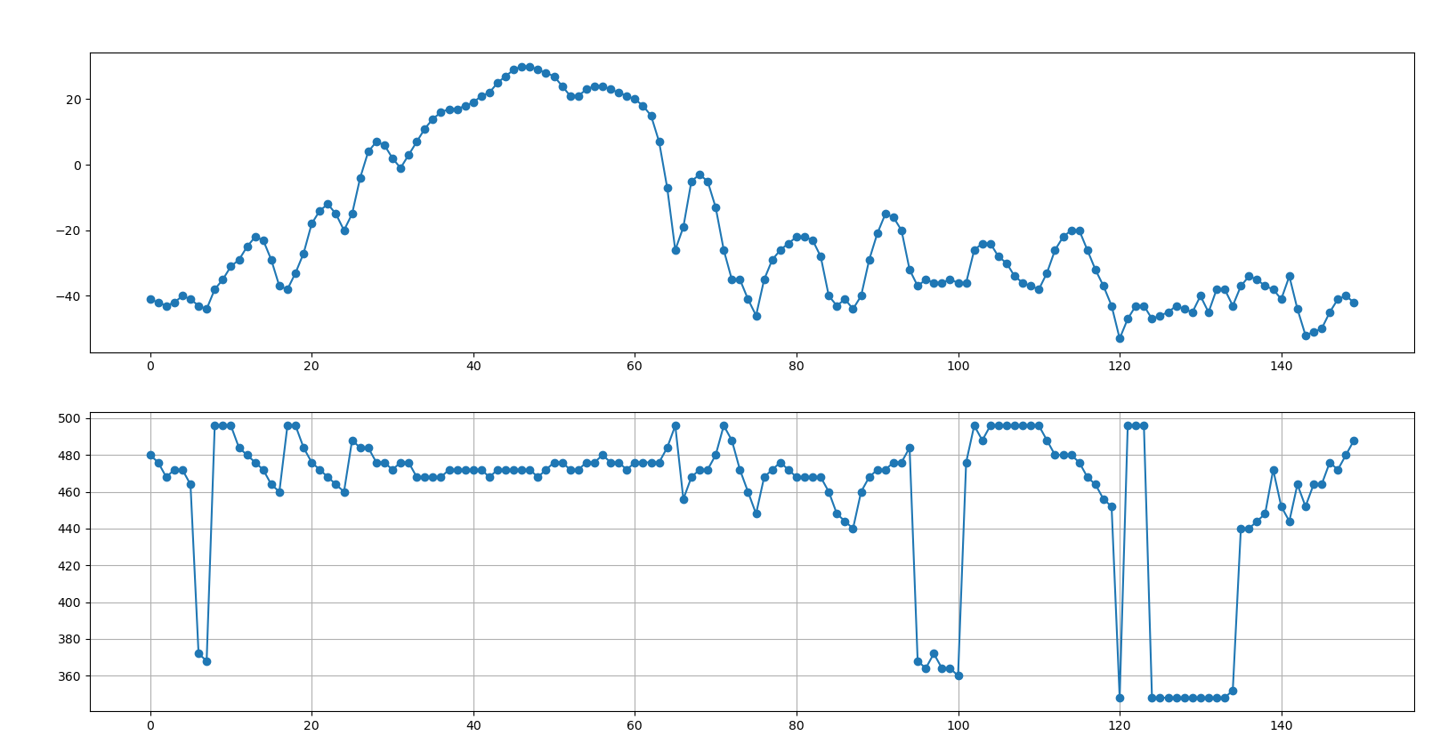

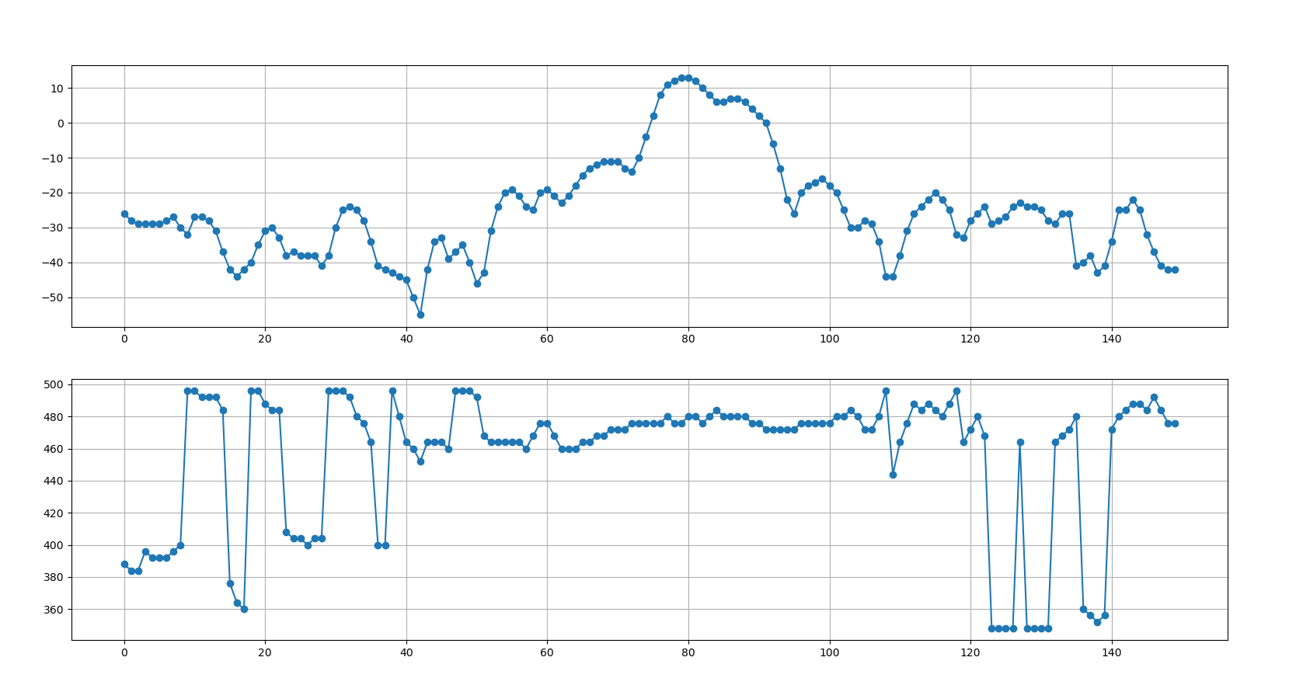

# Experiment # 2

2 screws closer

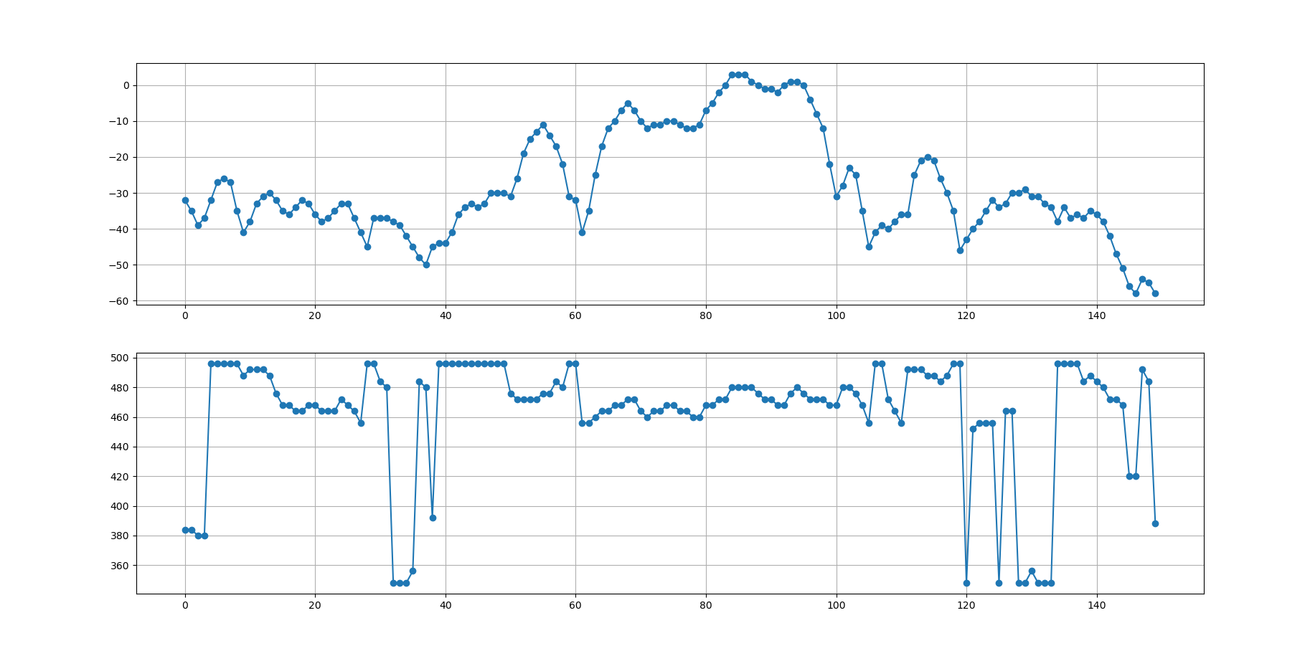

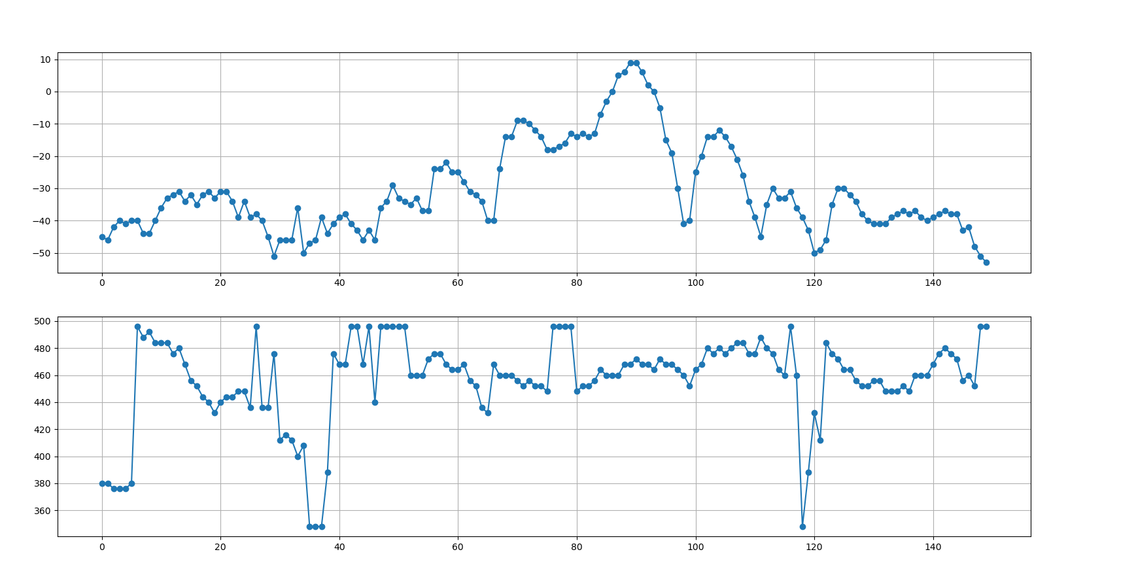

# Experiment 4

4 screws closer

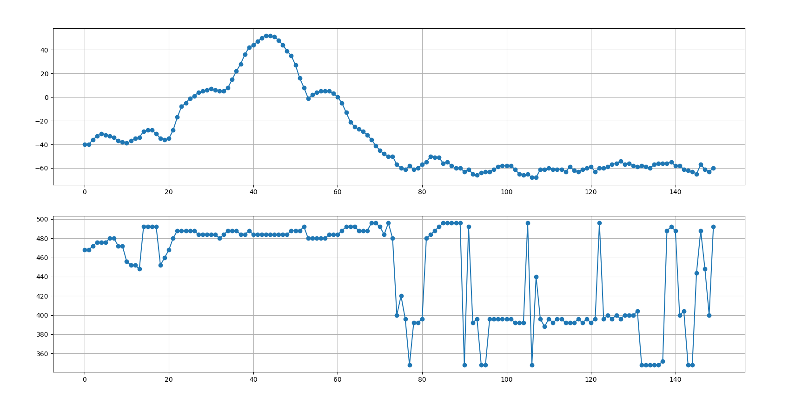

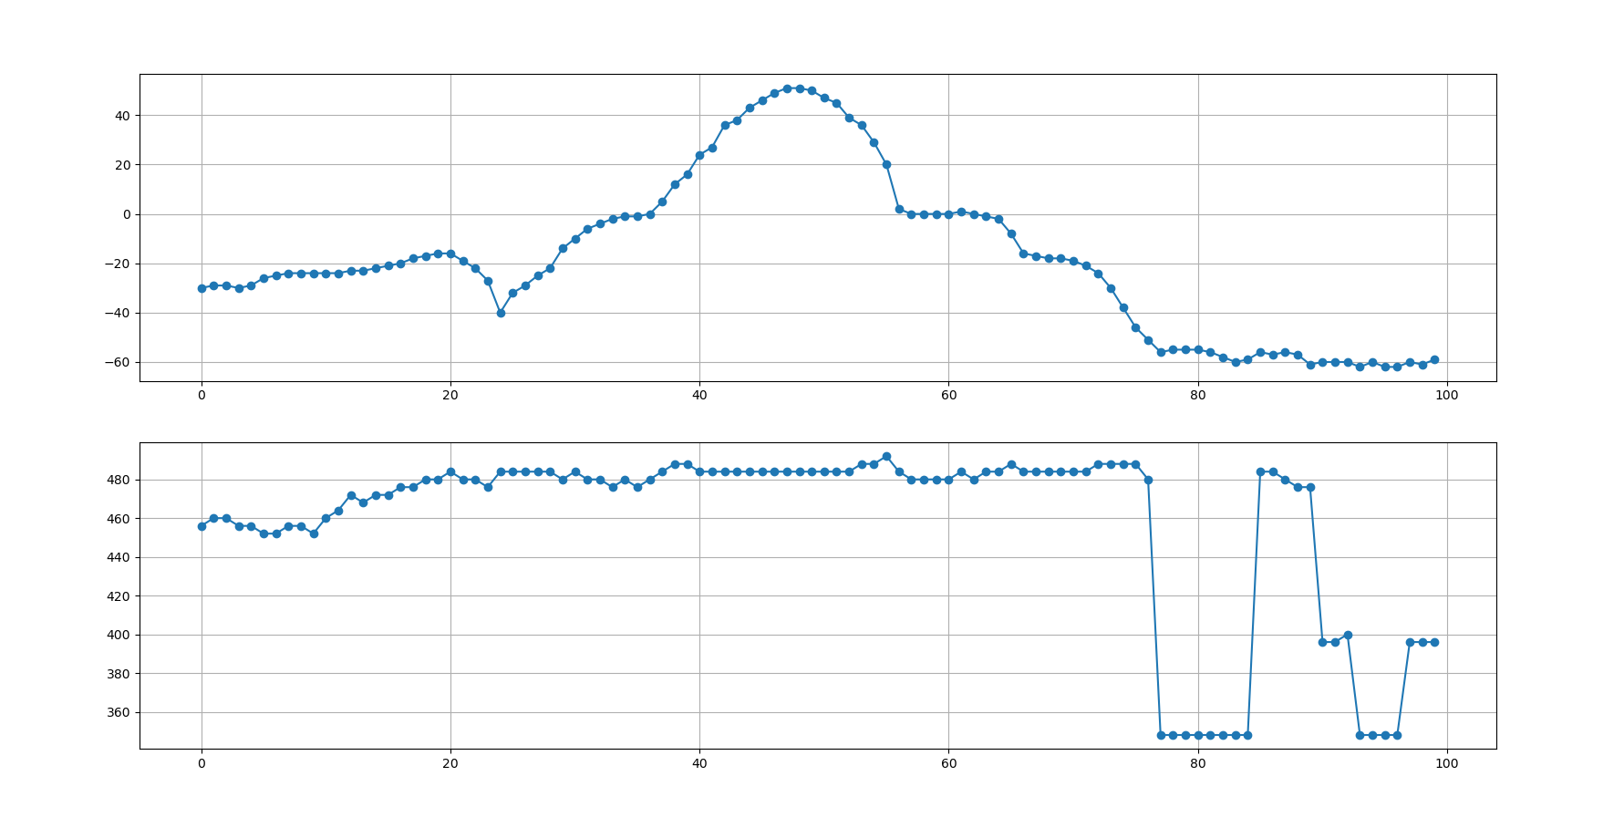

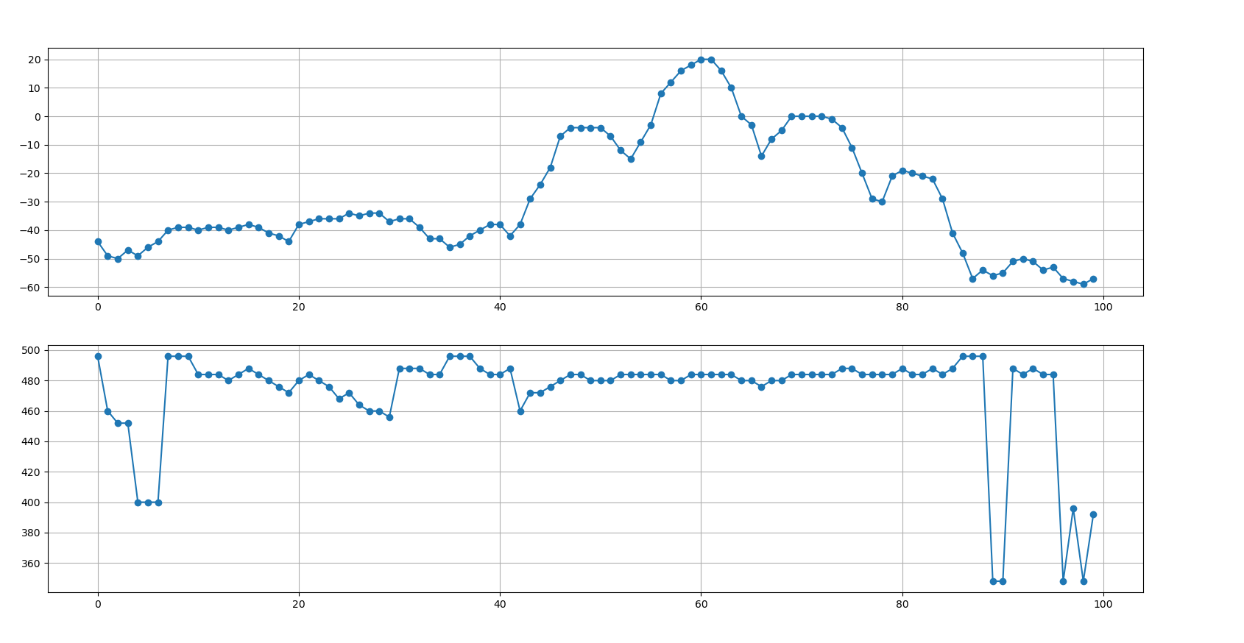

Entered at 45

Left at 47

# Experiment # 5

Screws as far as possible

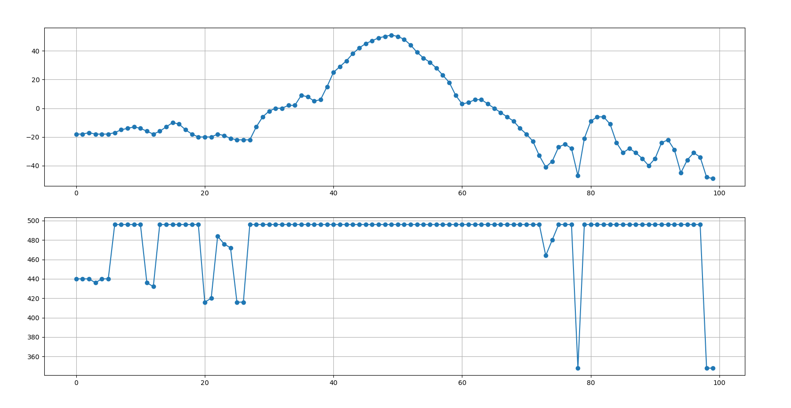

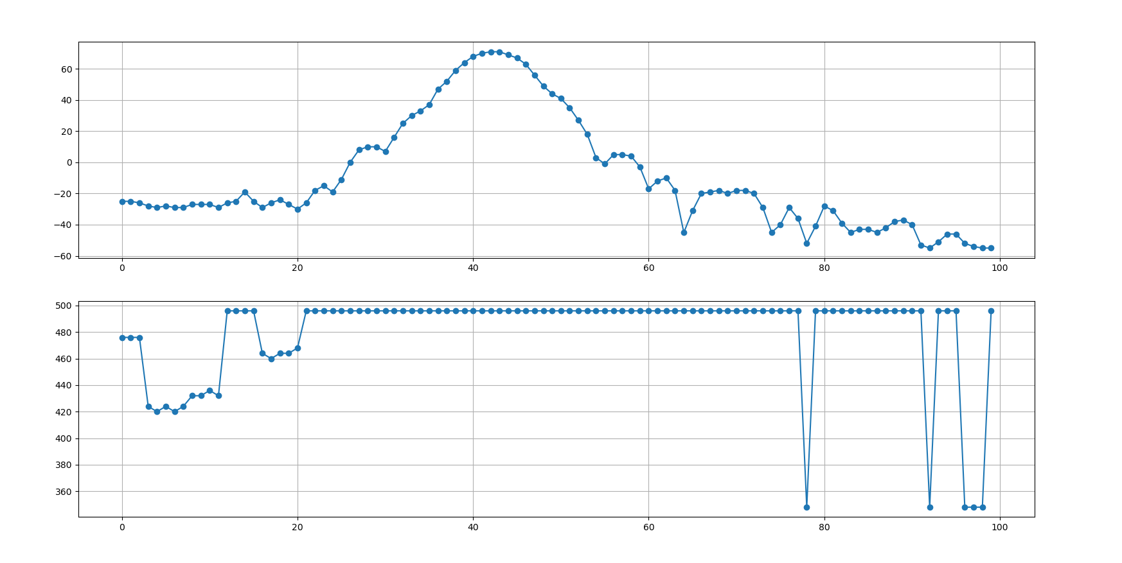

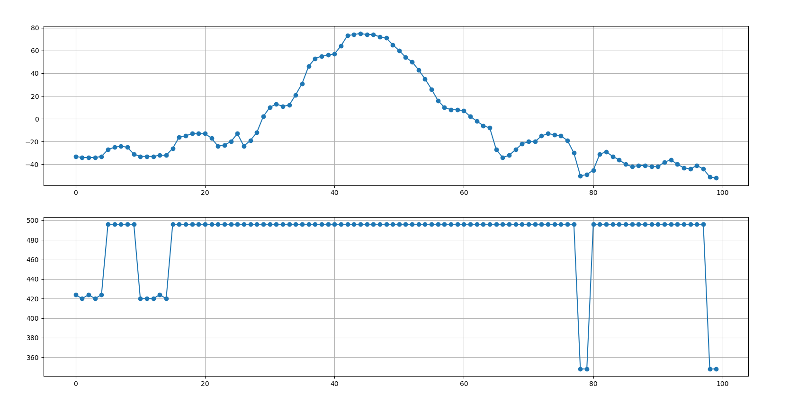

0 delay

# Experiment # 6

With 2 samolas

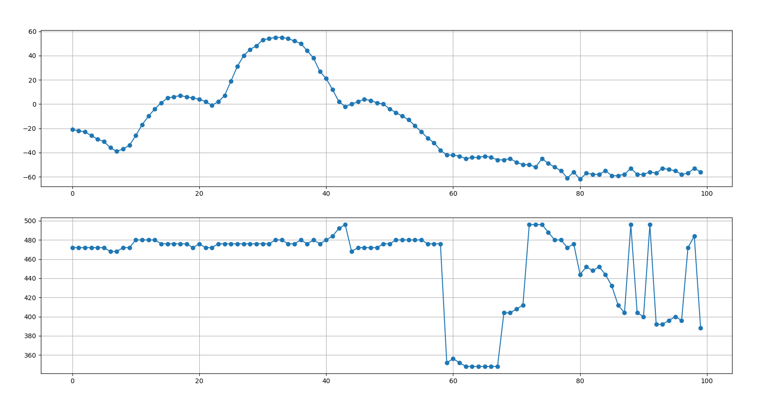

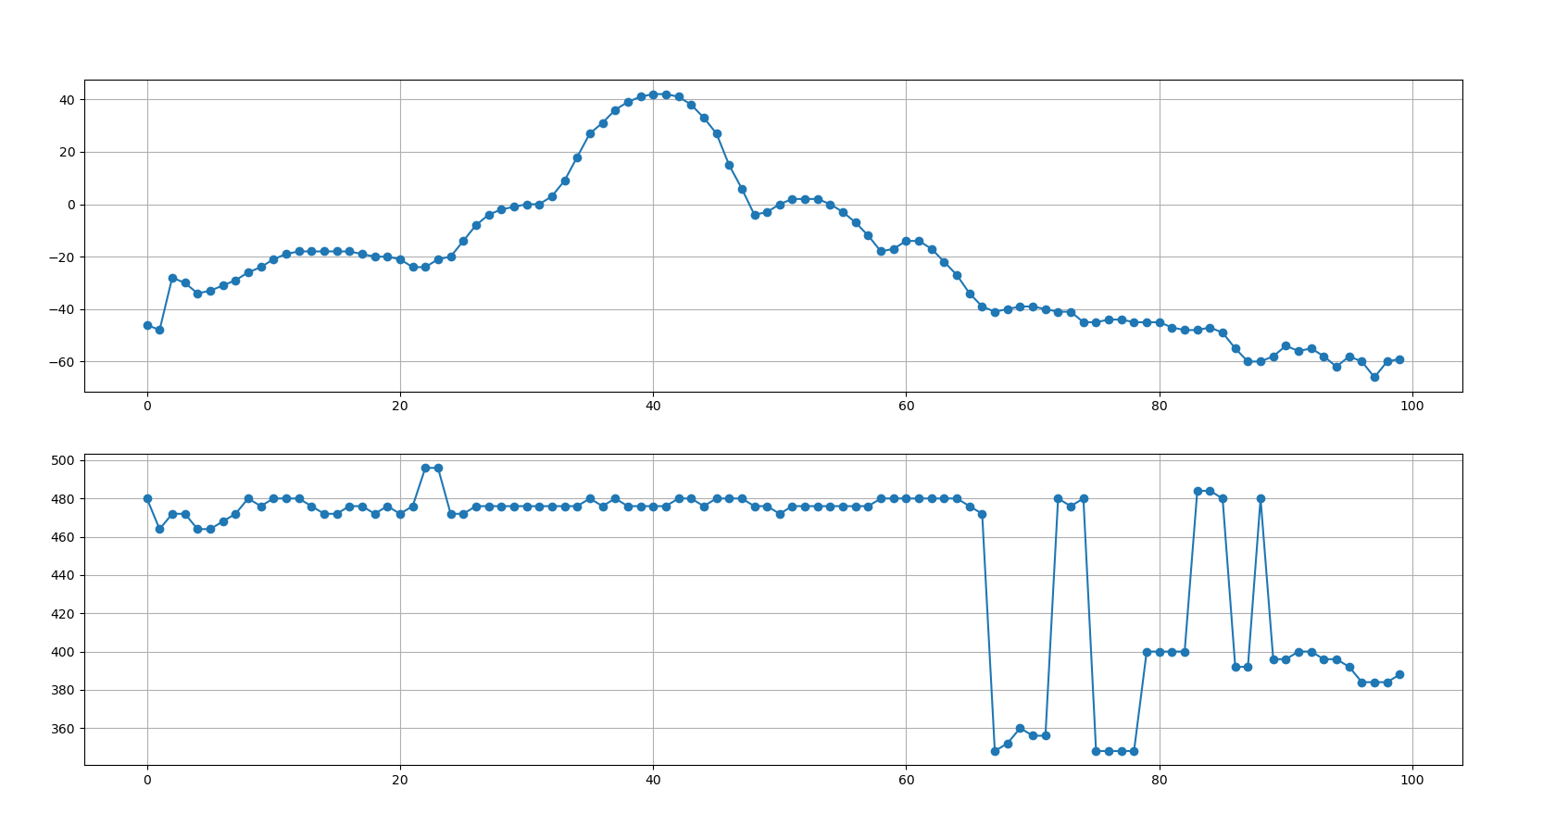

# Experiment # 8

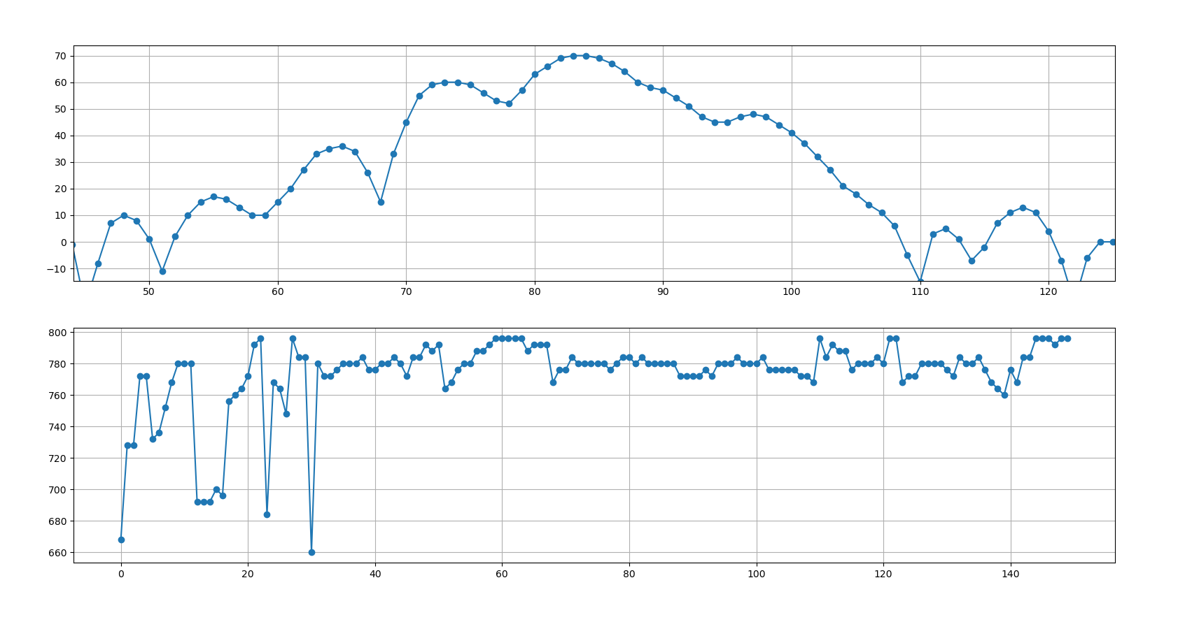

63 -> 97

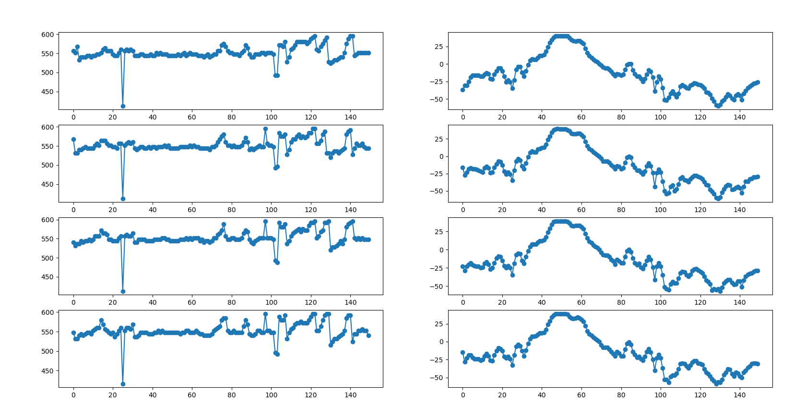

52—>54

Experiment in 3/2/2021 @ 8:21

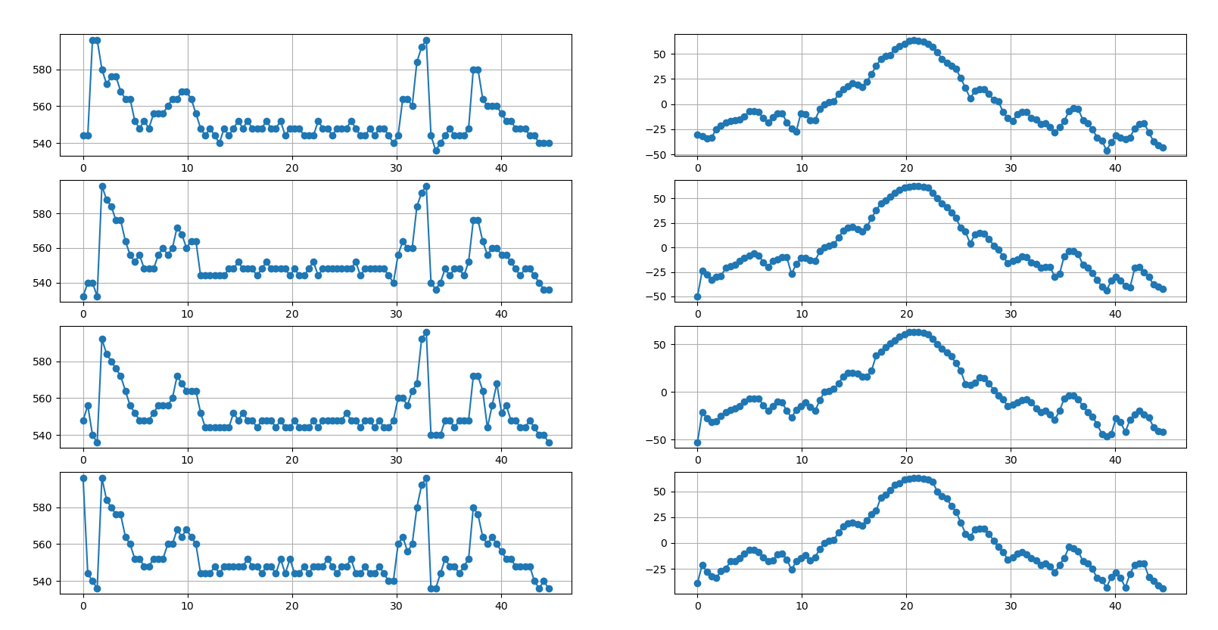

With 2 spacers with angel 45 step size =1

experement number ::0

[-30, -32, -34, -33, -25, -21, -18, -17, -16, -15, -12, -7, -7, -8, -14, -18, -13, -9, -9, -18, -24, -27, -9, -10, -16, -16, -5, 0, 2, 3, 10, 15, 18, 21, 19, 17, 22, 30, 38, 45, 48, 49, 55, 58, 60, 63, 64, 63, 62, 60, 57, 52, 45, 41, 38, 35, 26, 16, 6, 13, 15, 15, 10, 4, 3, -8, -14, -17, -10, -8, -8, -14, -15, -20, -19, -23, -28, -23, -17, -7, -4, -5, -16, -19, -25, -33, -36, -46, -38, -31, -33, -35, -33, -24, -20, -19, -28, -37, -41, -43]

[544, 544, 596, 596, 580, 572, 576, 576, 568, 564, 564, 552, 548, 552, 548, 556, 556, 556, 560, 564, 564, 568, 568, 564, 556, 548, 544, 548, 544, 540, 548, 544, 548, 552, 548, 552, 548, 548, 548, 552, 548, 548, 552, 544, 548, 548, 548, 544, 544, 544, 552, 548, 548, 544, 548, 548, 548, 552, 548, 544, 544, 548, 544, 548, 548, 544, 540, 544, 564, 564, 560, 584, 592, 596, 544, 536, 540, 544, 548, 544, 544, 544, 548, 580, 580, 564, 560, 560, 560, 556, 552, 552, 548, 548, 548, 544, 544, 540, 540, 540]

experement number ::1

[-50, -24, -28, -33, -30, -29, -21, -19, -18, -14, -11, -8, -6, -8, -15, -20, -14, -12, -10, -10, -27, -17, -11, -11, -13, -14, -4, 0, 2, 3, 10, 17, 20, 21, 19, 16, 21, 30, 38, 45, 48, 52, 56, 59, 61, 62, 63, 63, 62, 61, 56, 50, 45, 41, 36, 30, 20, 16, 4, 13, 15, 14, 9, 2, -2, -9, -16, -14, -12, -9, -10, -15, -17, -21, -20, -20, -30, -27, -9, -4, -4, -7, -18, -21, -26, -33, -40, -44, -34, -30, -34, -39, -41, -21, -20, -25, -30, -38, -40, -42]

[532, 540, 540, 532, 596, 588, 584, 576, 576, 564, 556, 552, 556, 548, 548, 548, 556, 560, 556, 560, 572, 568, 560, 564, 564, 544, 544, 544, 544, 544, 544, 548, 548, 552, 548, 548, 548, 544, 548, 552, 548, 548, 548, 548, 544, 548, 544, 544, 548, 552, 544, 548, 548, 548, 548, 548, 548, 548, 552, 544, 548, 548, 548, 548, 548, 544, 540, 556, 564, 560, 560, 584, 592, 596, 540, 536, 540, 548, 544, 548, 548, 544, 552, 576, 576, 564, 556, 560, 560, 556, 556, 552, 548, 544, 548, 548, 544, 540, 536, 536]

experement number ::2

[-53, -21, -28, -32, -31, -25, -21, -19, -17, -15, -10, -7, -7, -7, -14, -20, -15, -10, -11, -20, -27, -19, -15, -11, -16, -20, -9, 0, 1, 3, 9, 16, 20, 20, 19, 16, 16, 22, 38, 42, 47, 51, 54, 58, 60, 63, 63, 63, 62, 60, 56, 50, 45, 41, 37, 30, 22, 8, 7, 10, 15, 14, 9, 2, -4, -8, -15, -13, -11, -9, -8, -11, -17, -21, -20, -24, -29, -20, -7, -4, -4, -8, -15, -21, -26, -34, -44, -47, -44, -28, -32, -42, -29, -24, -20, -24, -27, -37, -41, -42]

[548, 556, 540, 536, 592, 584, 580, 576, 572, 564, 556, 552, 548, 548, 548, 552, 556, 556, 556, 560, 572, 568, 564, 564, 564, 552, 544, 544, 544, 544, 544, 544, 552, 548, 552, 548, 548, 544, 548, 548, 548, 544, 548, 544, 544, 548, 544, 544, 544, 548, 544, 548, 548, 548, 548, 548, 552, 548, 548, 544, 548, 548, 544, 548, 544, 544, 548, 560, 560, 556, 564, 568, 592, 596, 540, 540, 540, 548, 548, 544, 548, 548, 548, 572, 572, 564, 544, 556, 568, 552, 556, 548, 548, 544, 544, 548, 544, 540, 540, 536]

experement number ::3

[-39, -21, -28, -32, -34, -27, -25, -18, -18, -15, -10, -7, -7, -9, -14, -18, -17, -11, -10, -16, -26, -18, -15, -12, -17, -14, -6, 0, 2, 3, 10, 16, 19, 20, 18, 17, 22, 28, 31, 44, 47, 51, 56, 58, 61, 62, 63, 63, 62, 61, 59, 50, 45, 43, 36, 30, 20, 9, 6, 13, 14, 14, 9, 2, -4, -9, -16, -14, -10, -9, -11, -15, -17, -21, -20, -23, -29, -21, -15, -4, -5, -8, -18, -20, -25, -34, -36, -43, -33, -29, -34, -43, -30, -21, -20, -20, -33, -37, -41, -44]

[596, 544, 540, 536, 596, 584, 580, 576, 576, 564, 560, 552, 552, 548, 548, 552, 552, 552, 560, 560, 568, 564, 568, 564, 560, 544, 544, 544, 548, 544, 548, 548, 548, 548, 548, 552, 548, 548, 544, 548, 548, 544, 552, 544, 552, 544, 544, 548, 544, 548, 548, 548, 552, 548, 544, 548, 548, 552, 544, 544, 548, 544, 544, 548, 544, 540, 540, 560, 564, 556, 560, 580, 592, 596, 536, 536, 544, 552, 548, 548, 544, 548, 552, 580, 576, 564, 560, 564, 560, 556, 552, 552, 548, 548, 548, 548, 540, 536, 540, 536]

Experiment in 3/2/2021 @ 8:49

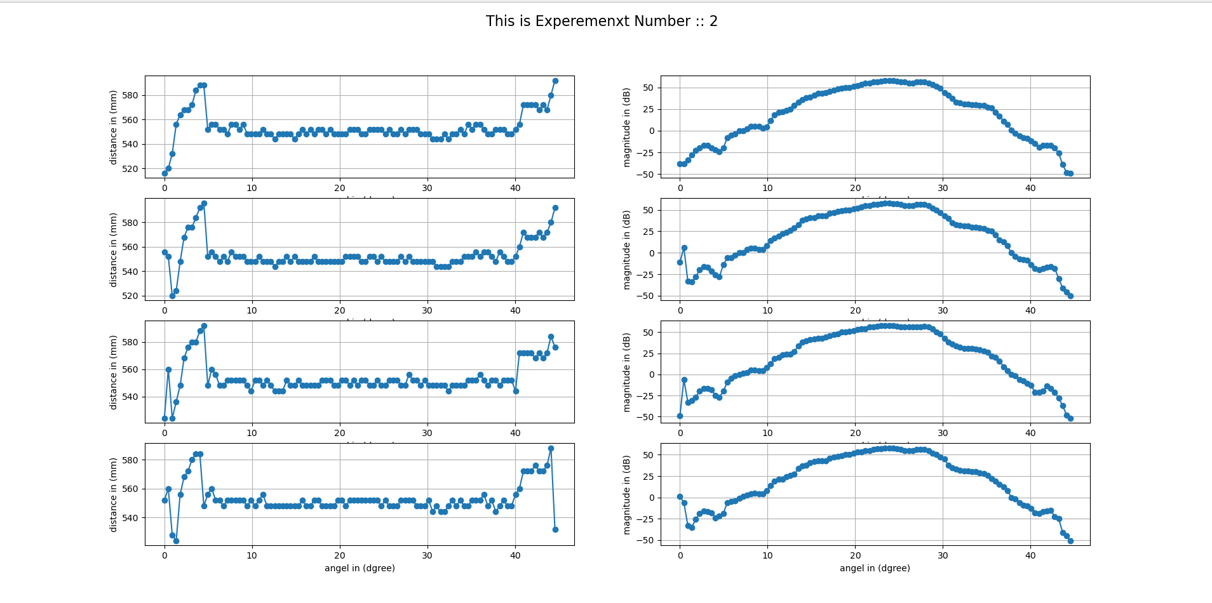

With 1 spacers with angel 45 step size =1

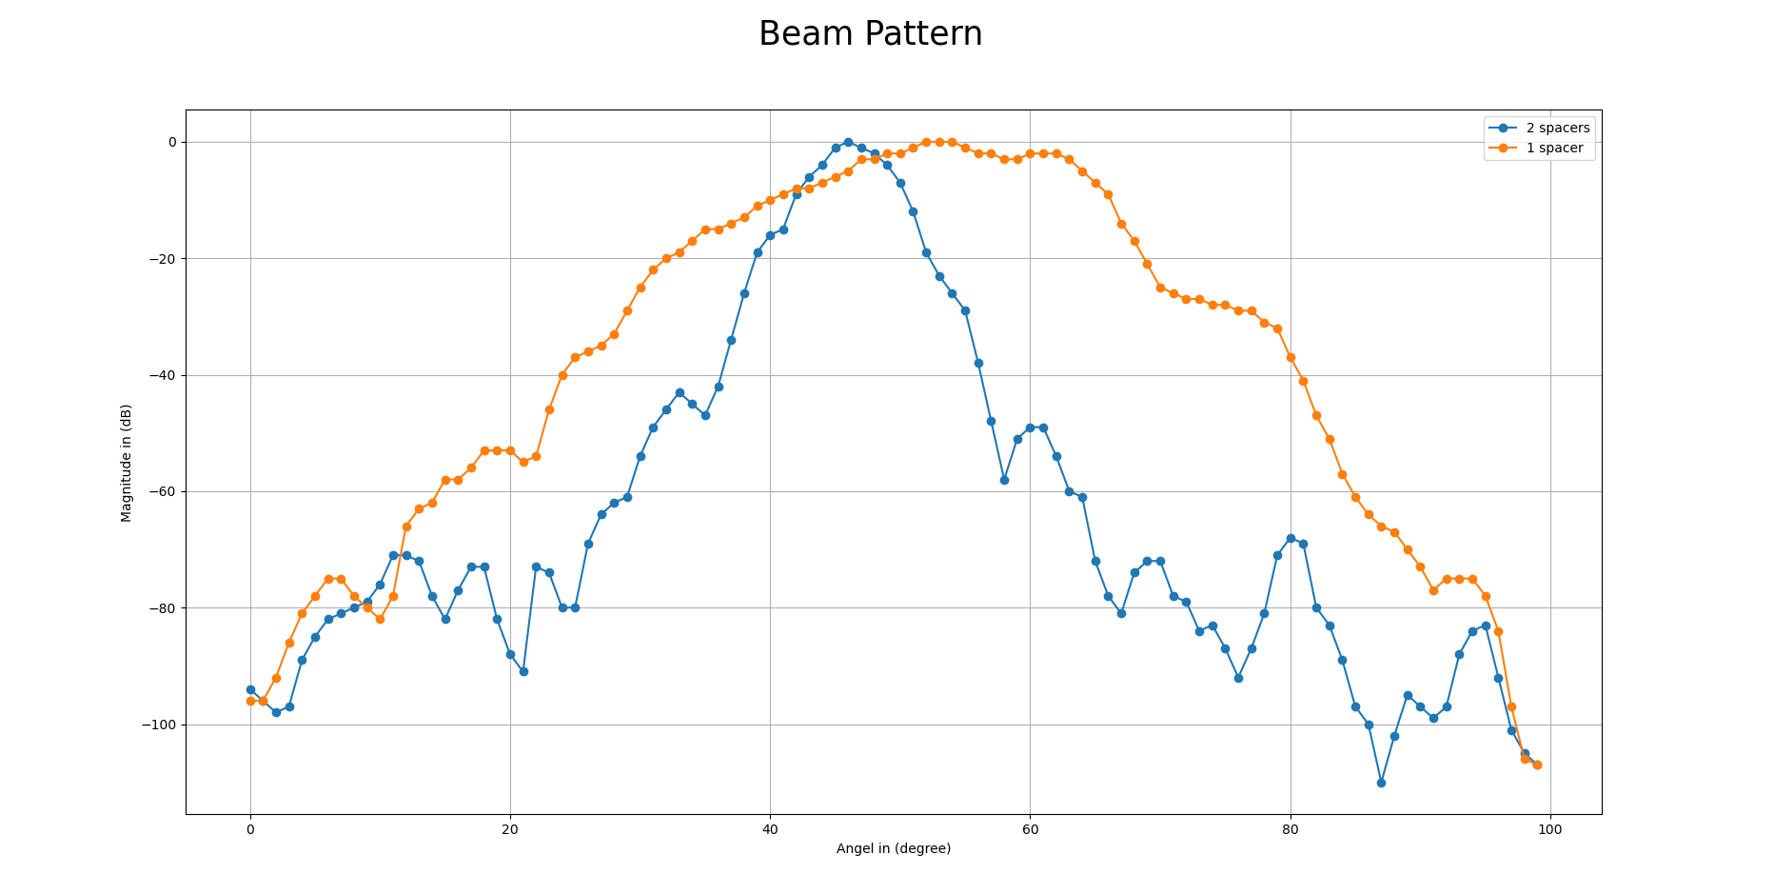

Experiment in 3/2/2021 @ 9:21

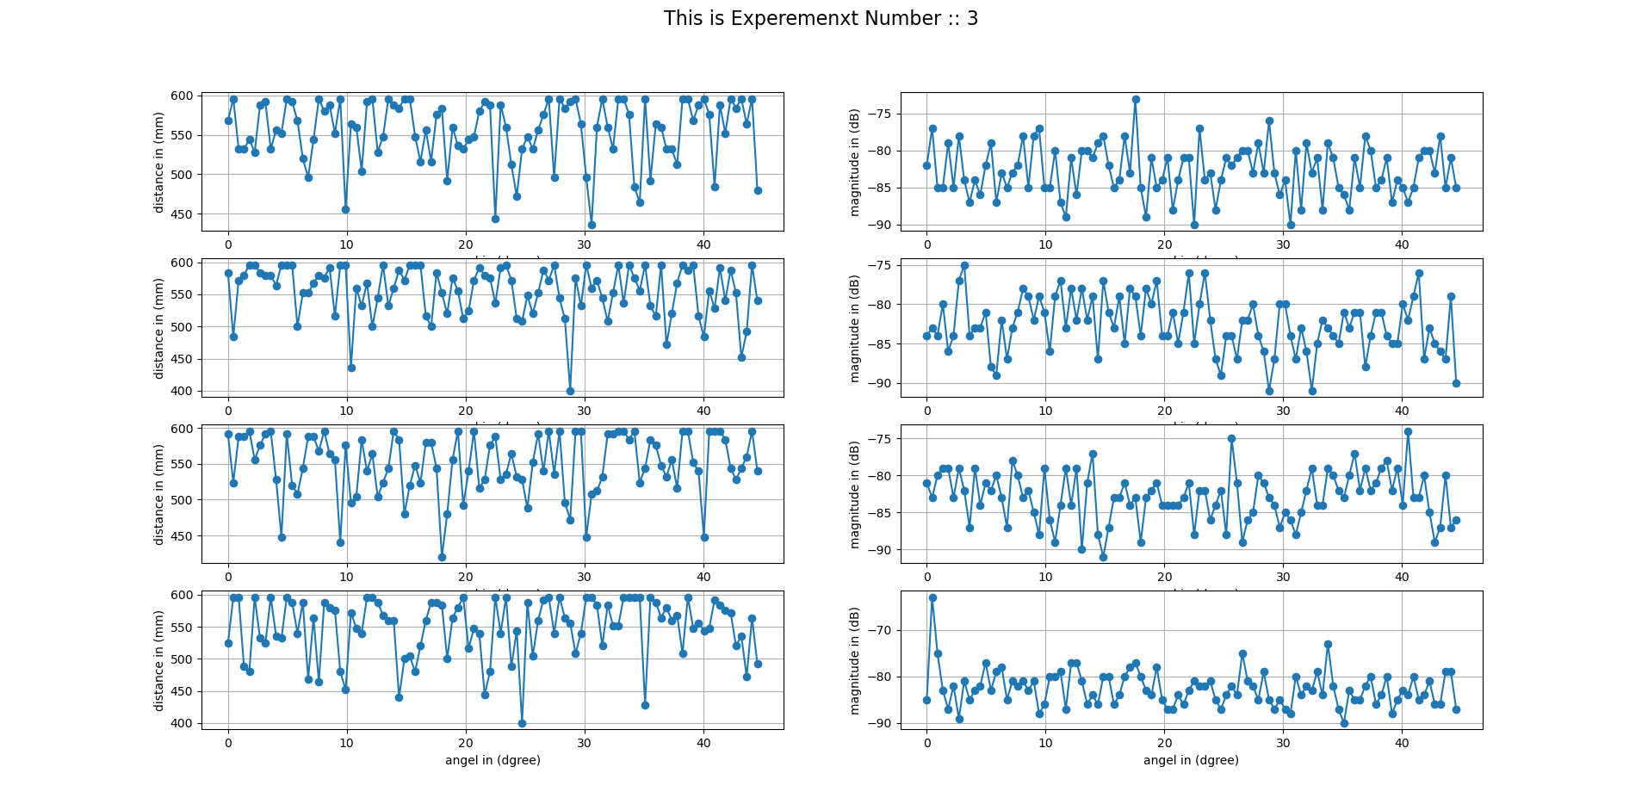

With 3 spacers with angel 45 step size =1

Experiment in 3/2/2021 @ 9:36

With 2 spacers with angel 45 step size =1

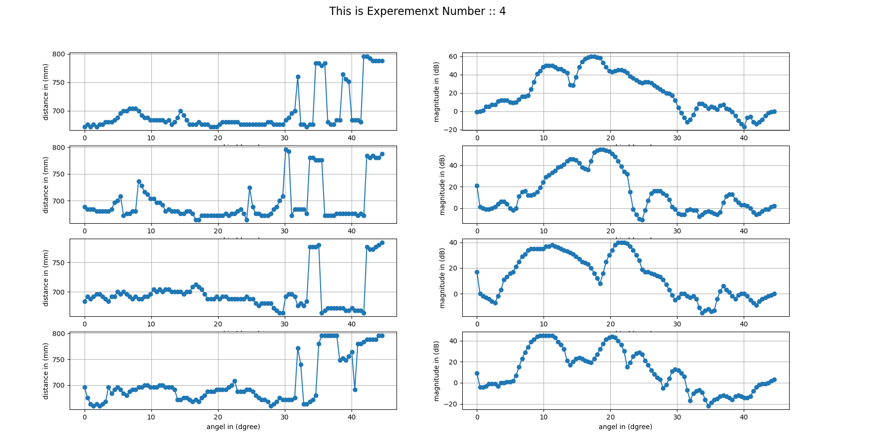

Experiment in 3/2/2021 @ 9:56

With 2 spacers with angel 45 step size =1

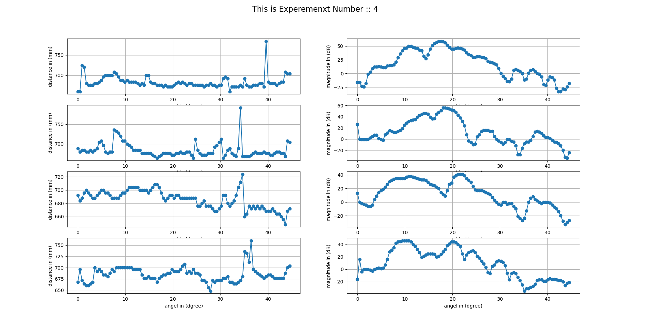

Experiment in 3/2/2021 @ 10:12

With 2 spacers with angel 67.5 step size =1

Won’t have readings in the Experements.txt file because we don’t save readings in if n == 1

We only save for more than 2

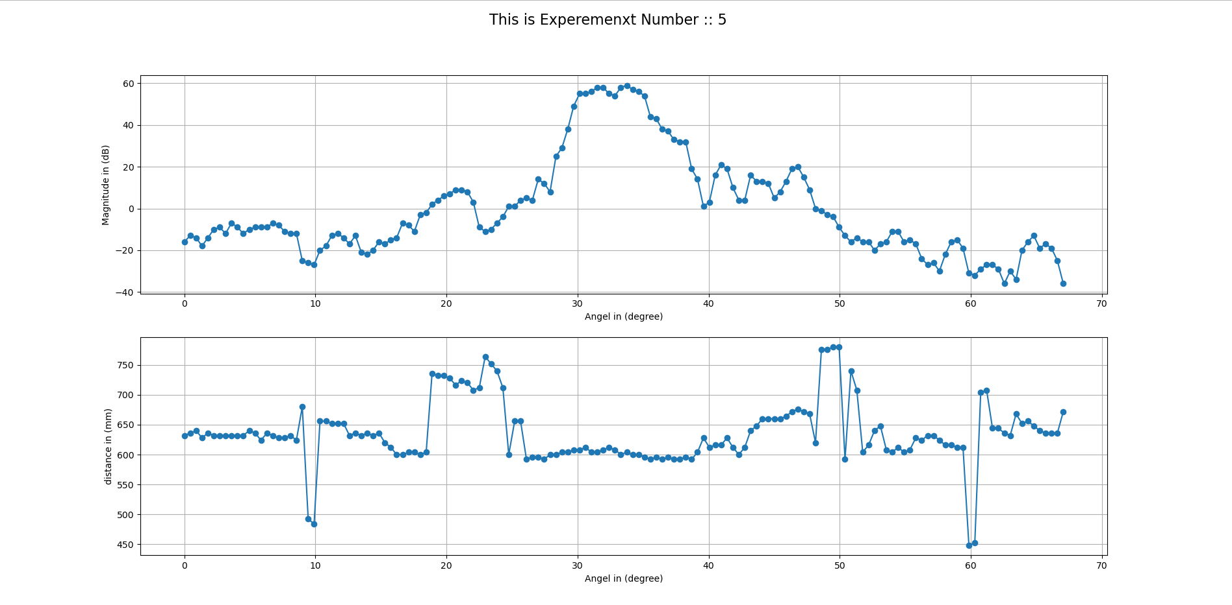

Experiment in 4/2/2021 @ 2:56PM With 2 spacers with angel 67.5 step size =1 number of iterations = 3

In_steps = 60 center_steps =90 out_steps = 112

position number #1

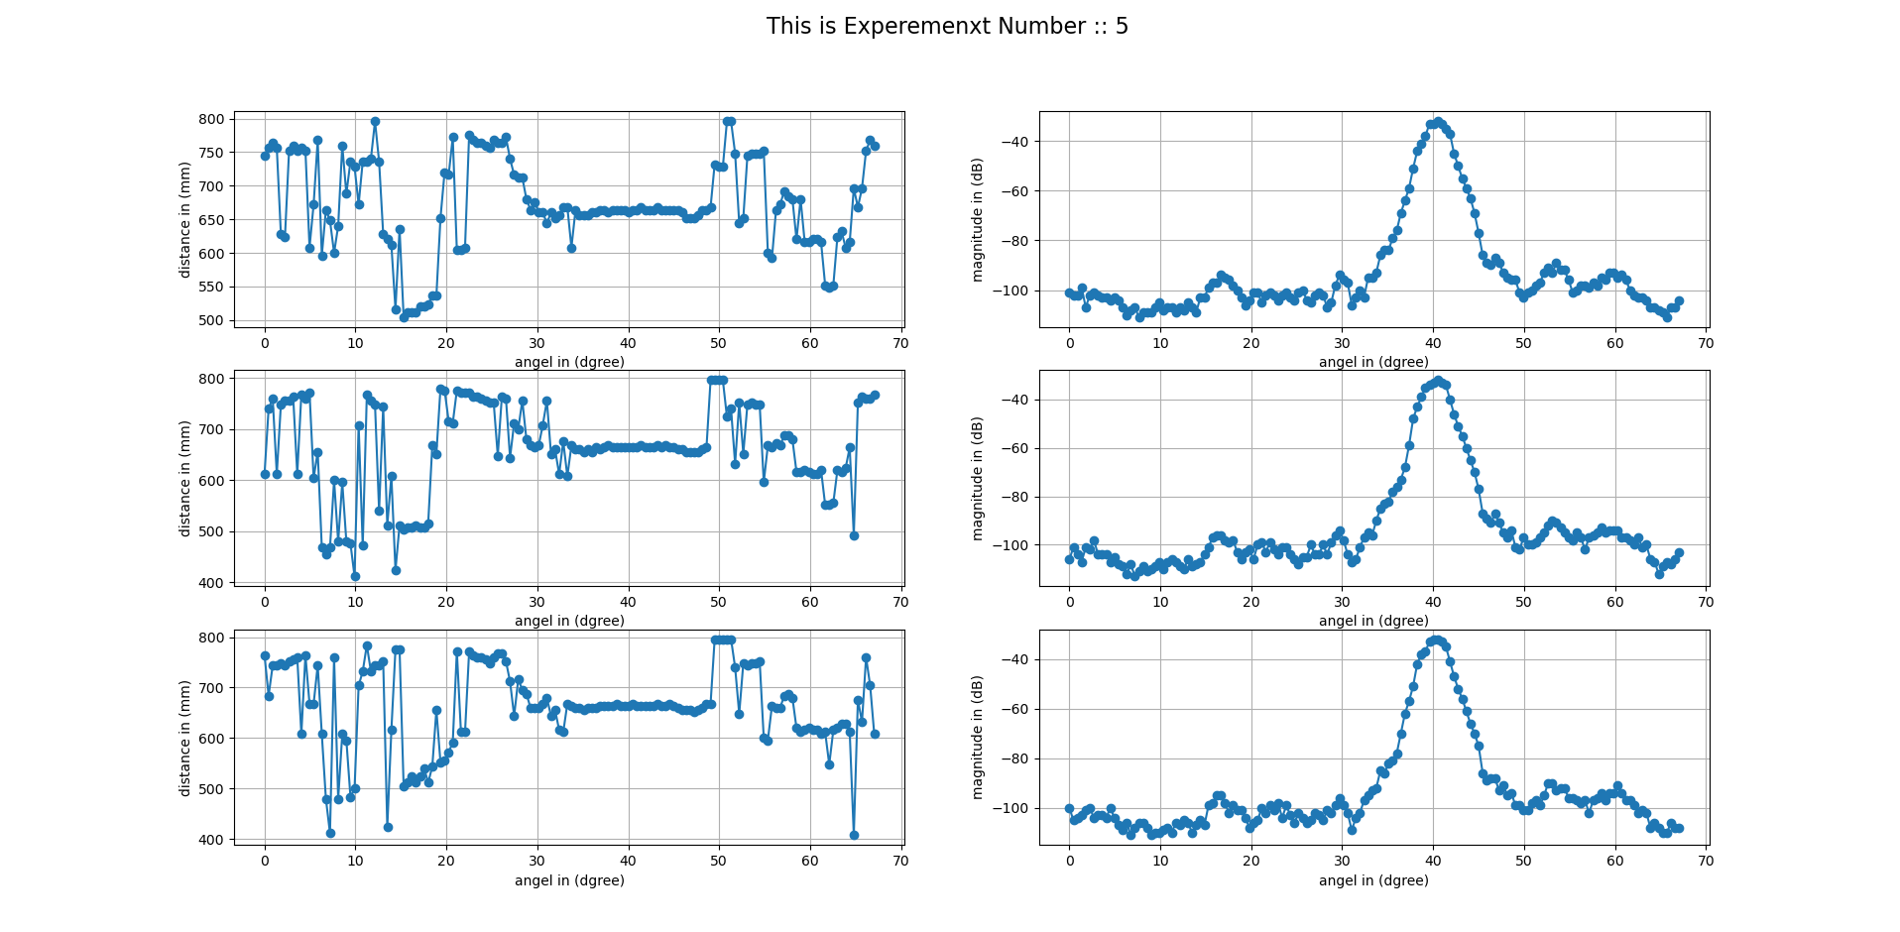

Experiment in 4/2/2021 @ 3:04PM With 2 spacers with angel 67.5 step size =1 number of iterations = 3

In_steps = 73 out_steps =106

Step up

position number #2

Length = 20

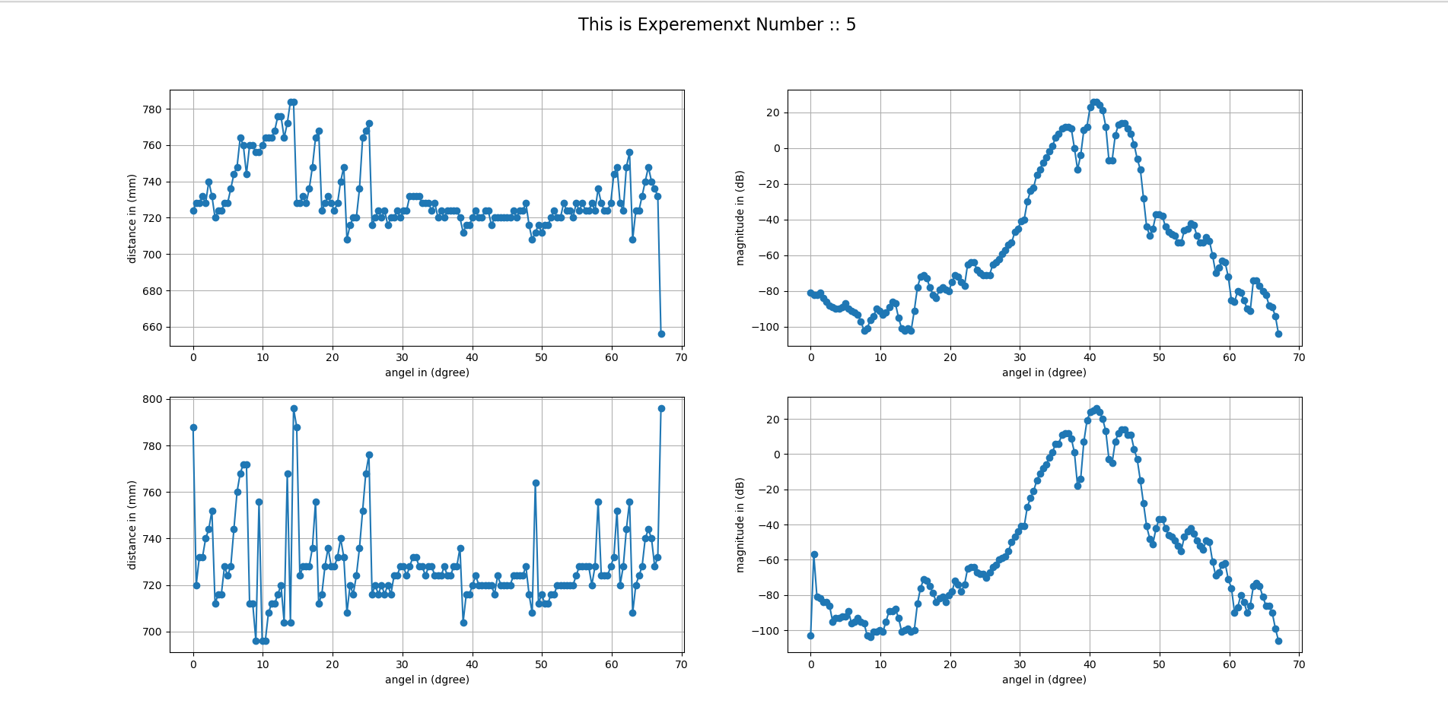

Experiment in 4/2/2021 @ 3:07PM With 2 spacers with angel 67.5 step size =1 number of iterations = 3

Step up

In = 64, out = 111

Position number #3

Length = 30

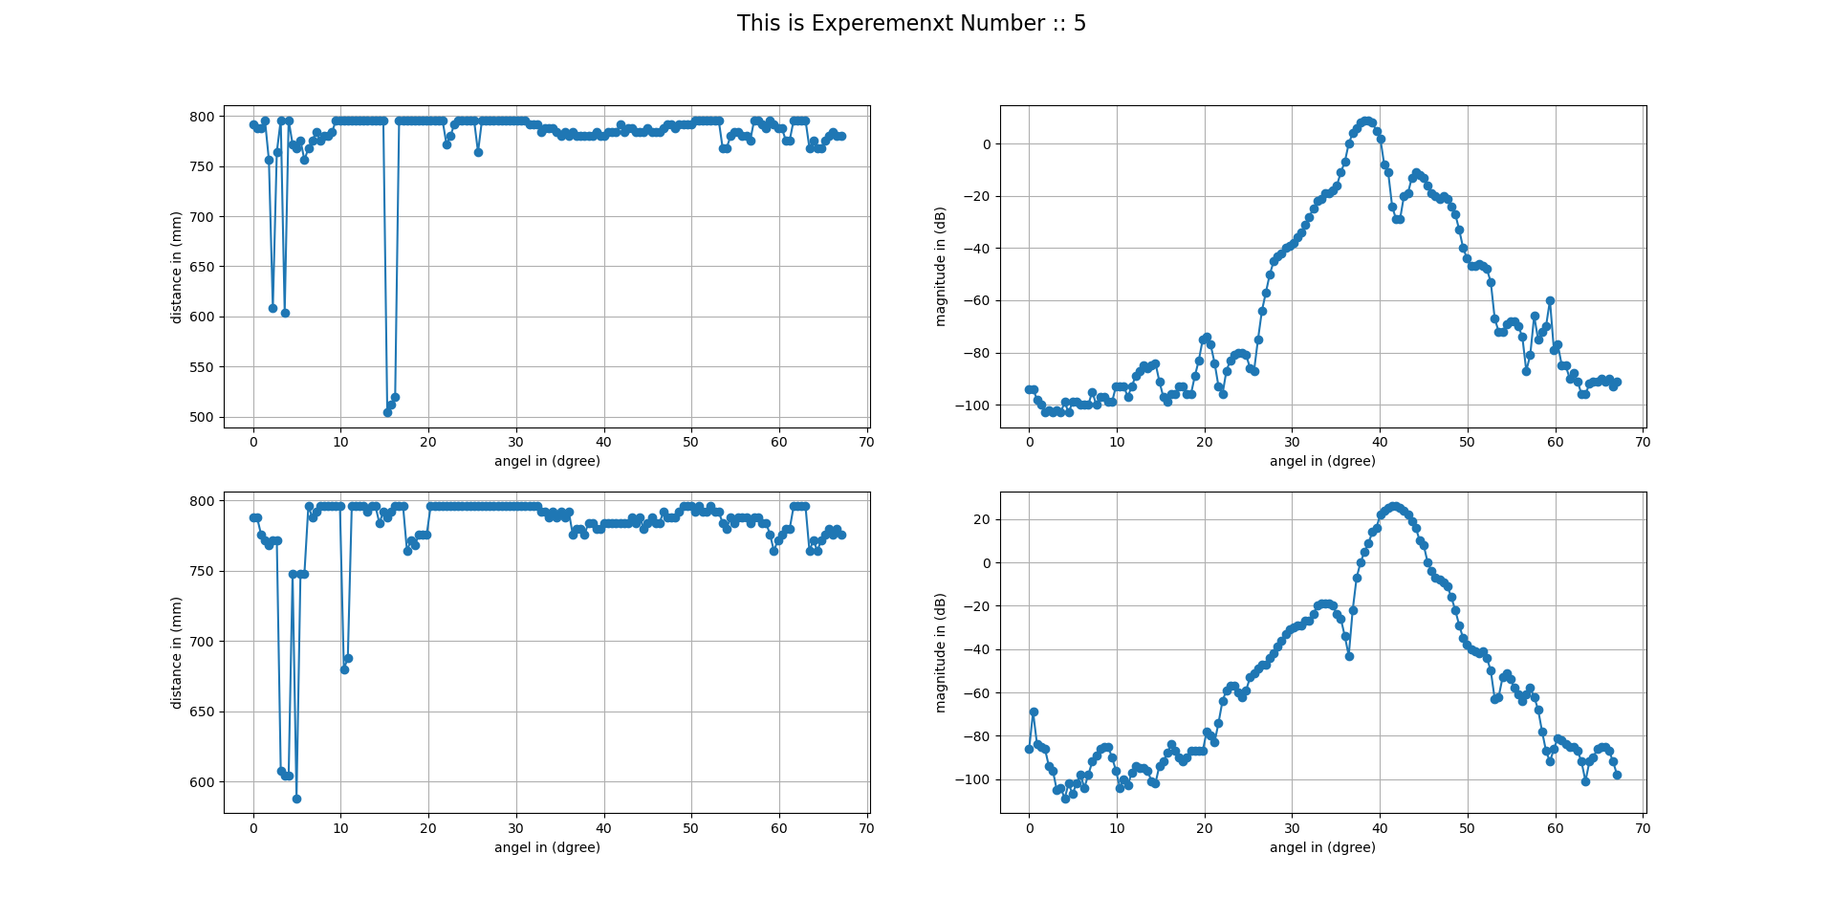

Experiment in 4/2/2021 @ 6:30PM With 2 spacers with angel 67.5 step size =1 number of iterations = 2

Step up

In = 64, center = 86 out =114 , threshold = 0.48 , AGC = ON

Position number #1

with CFAR

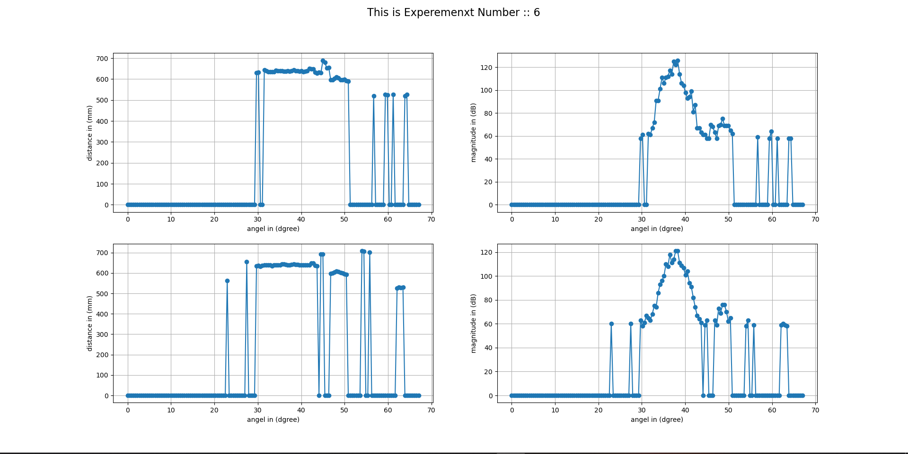

Experiment in 4/2/2021 @ 6:46PM With 2 spacers with angel 67.5 step size =1 number of iterations = 2

Step up

In = 64, center = 86 out =114 , threshold = 0.46 , AGC = ON

Position number #1

with CFAR